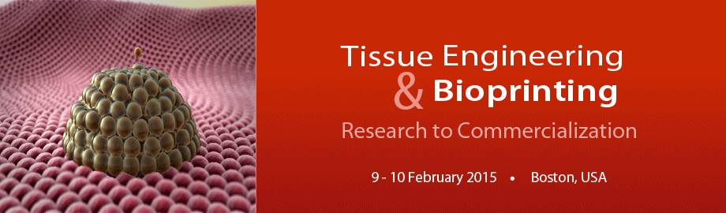

Select Biosciences is bringing together the top researchers in the tissue engineering and 3D-bioprinting fields in its Tissue Engineering & Bioprinting: Research to Commercialization conference to be held in Boston, February 9-10, 2015.

This Conference is Composed of Two Concurrent Tracks and Delegates can Mix-and-Match Presentations from Both Tracks Plus Network with Attendees from Both Tracks:

- Emerging Themes and Technologies in Tissue Engineering and Bioprinting
- Clinical Applications and Clinical Translation of Tissue Engineering

Topics Covered in this Conference
- Biofabrication and Medical Bioprinting Technologies and Bioinks – Novel Technologies and Emerging Approaches in the 3D-Bioprinting Field
- Bioprinters and Bioinks
- Medical and Non-Medical Applications of 3-D Bioprinted Products
- Patent Landscape of the 3D-Bioprinting Field
- Perspectives from the Practicing Clinicians and Surgeons in the Field
- Tissue Engineering and its Clinical Translation: Impact on Cardiovascular Disease, Orthopedic, Skin, Dermatological, Wound Healing and Sports Medicine
- Tissue Engineering Technologies and Products: In Development and Commercialized

Confirmed Keynote Speakers
- Dietmar Hutmacher, Professor & Chair in Regenerative Medicine, Queensland University of Technology, Australia. Melt Electrospinning in a Direct Writing Mode – A New Additive Manufacturing Technology Platform
- Gabor Forgacs, George H. Vineyard Professor of Biophysics, University of Missouri. Tissue Fabrication and Bioprinting Beyond Regenerative Medicine
- Geraldine Hamilton, President and Chief Scientific Officer, Emulate. Organs-on-Chips: Highly Functional Micro-physiological Systems to Predict Human Physiology and Pathobiology
- Hod Lipson, Professor of Engineering, Cornell University. The Next 25 Years of 3D Printing
- Keith Murphy, Chairman and CEO, Organovo. Commercial Opportunities for Bioprinting
- Mark Berman, Cell Surgical Network, Past-President—American Academy of Cosmetic Surgery. Point-of-Care Surgical Tissue Reconstruction: A Roadmap for the Industry and the Regulatory Authorities
- Todd McAllister, President and CEO, Cytograft Tissue Engineering. Commercialization Challenges in Regenerative Medicine: How do we fund companies that take decades to develop successful clinical treatments?

Confirmed Speakers Include
- Adam Hacking, Chief Scientific Officer, Oxford Performance Materials (OPM)
- Danny Cabrera, CEO, BioBots, Inc.
- Dennis Lox, Physician, Florida Spine and Sports Medicine Center
- Eric Darling, Manning Assistant Professor of Medical Science, Orthopaedics, and Engineering, Brown University
- Fabien Guillemot, CEO, Poietis-France
- George Truskey, R. Eugene and Susie E. Goodson Professor of Biomedical Engineering, Duke University
- Jeff Morgan, Professor of Medical Science and Engineering, Brown University
- Jeffrey Lipton, Founder & Chief Technology Officer, SERAPH ROBOTICS
- Jennifer Lewis, Hansjörg Wyss Professor, Harvard University, School of Engineering and Applied Sciences
- John Fisher, Fischell Family Distinguished Professor and Associate Chair, University of Maryland
- Jon Rowley, Chief Executive and Technology Officer, RoosterBio
- Jonathan Butcher, Associate Professor, Cornell University
- Jos Malda, Associate Professor, University Medical Center Utrecht-The Netherlands
- Joseph Purita, Director, Institute Of Regenerative and Molecular Orthopedics
- Joyce Wong, Professor, Boston University
- Kelly Stevens, Research Scientist, Massachusetts Institute of Technology (MIT)
- Lorenzo Moroni, Associate Professor, Maastricht University-The Netherlands
- Mark DeCoster, James E. Wyche III Endowed Associate Professor in Biomedical Engineering, Louisiana Tech University
- Oren Levy, Instructor of Medicine, Harvard Medical School
- Paul Calvert, Professor of Bioengineering, University of Massachusetts-Dartmouth
- Paul Gatenholm, Professor, Chalmers University, Adjunct Professor Wake Forest Institute for Regenerative Medicine
- Rashid Bashir, Abel Bliss Professor, Bioengineering and Electrical and Computer Engineering, University of Illinois at Urbana-Champaign
- Robert Esmond, Director, Sterne, Kessler, Goldstein & Fox P.L.L.C.
- Roger Kamm, Professor, Massachusetts Institute of Technology (MIT)
- Rong Fan, Associate Professor, Yale University
- Sharon Presnell, CTO & Executive Vice President R&D, Organovo
- Stuart Williams, Director, Bioficial Organs, University of Louisville
- Warren Grayson, Assistant Professor, Biomedical Engineering and Material Sciences & Engineering, Johns Hopkins University School of Medicine

To Register, Please Contact

Jeff Fan
Events Manager
SELECTBIO US
Telephone: 510-857-4865
Jeff@selectbio.us

